Comparative Study of Old Kingdom Egyptian and Neo-Sumerian Sculptures
Introduction
Sculpture has long served as a window into the cultural values and spiritual beliefs of ancient societies, allowing us to glimpse how they defined power, memory, and devotion. The Old Kingdom Egyptian statue of Memi and Sabu and the Neo-Sumerian statue of Gudea are striking examples of how artistic form and intended function intertwine. Although crafted in different eras and regions, both sculptures share the goal of commemorating their subjects and expressing their societal roles. However, the unique purposes behind each sculpture greatly influenced their appearance and style, revealing much about the civilizations that produced them. By examining these statues alongside each other, we can gain a deeper understanding of how function shapes artistic choices and cultural expression, paving the way for a more nuanced discussion of their form and symbolism
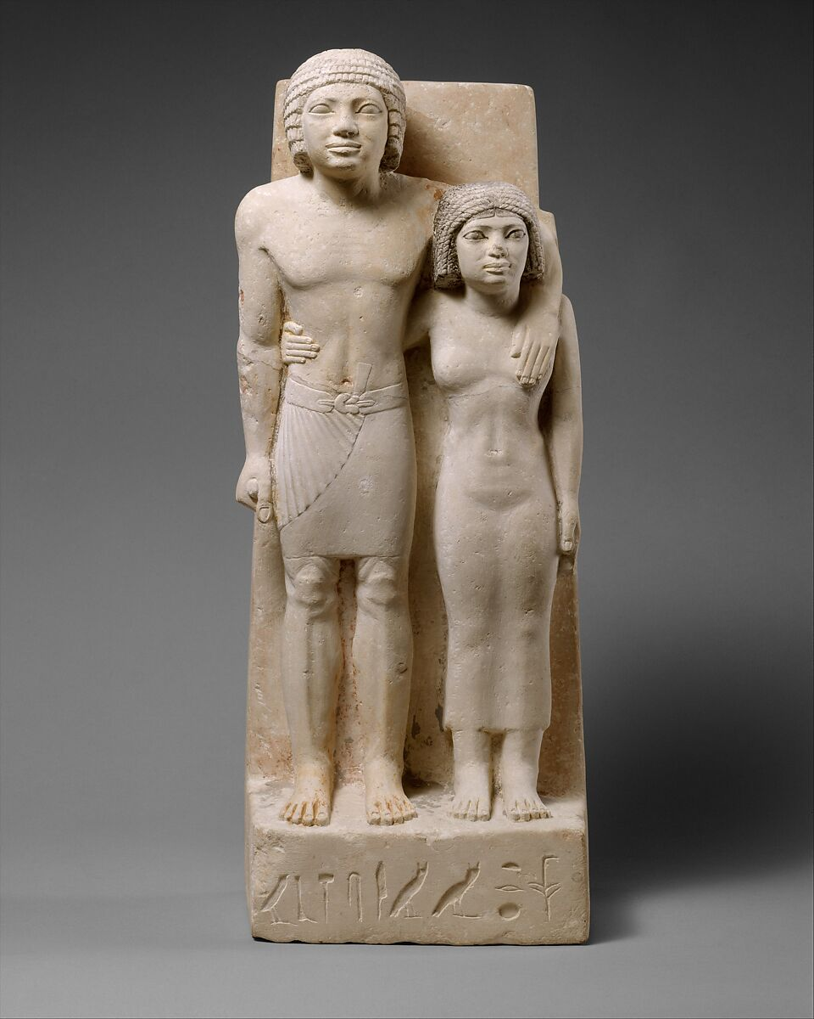  Statue of Memi and Sabu | 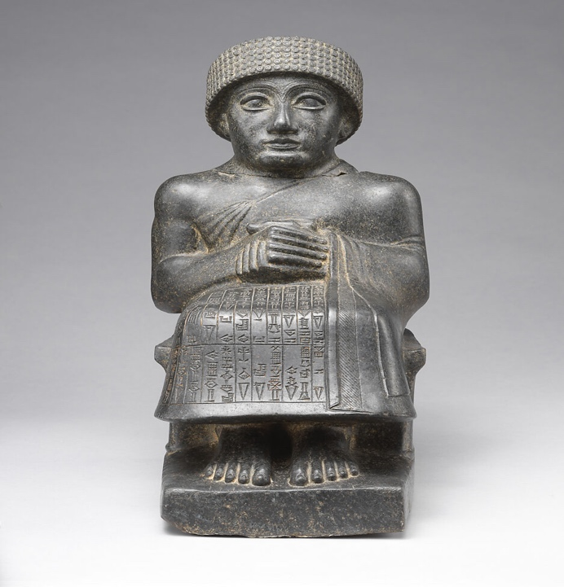  Seated Statue of Gudea

The choice of materials in both sculptures reflects their underlying purpose. Memi and Sabu’s statue was carved from limestone, a commonly used material in Egypt that allowed for detailed carving and expressive features suitable for commemorative art (Metropolitan Museum of Art, 2024a). This material permitted the artists to capture the subtleties of the figures’ expressions and postures, reinforcing the intimacy and personal nature of the statue. In contrast, Gudea’s statue was fashioned from diorite, a much harder stone that required great skill to work and symbolized enduring authority (Metropolitan Museum of Art, 2024b). The durability of diorite not only ensured the longevity of the statue but also communicated Gudea’s lasting power and divine favor. Both choices reveal how the properties of materials were harnessed to reinforce each statue’s specific message, preparing us to consider how posture and expression contribute to their distinct purposes.
The pose and expression of Memi and Sabu are naturalistic and inviting, with almond-shaped eyes and subtle smiles. Their stride forward suggests movement and vitality, in keeping with Egyptian artistic conventions focused on portraying subjects as youthful and serene for their journey into the afterlife. The woman’s oblique gaze and the man’s protective gesture create a sense of individuality and relationship, further reinforcing the commemorative function of the sculpture (Metropolitan Museum of Art, 2024a). This idealization of the human form stands in contrast to Gudea’s calm, prayerful posture and stylized body.
Gudea appears seated, his hands clasped together in a gesture of humility and devotion, highlighting the Neo-Sumerian emphasis on piety and religious legitimacy. His bare feet, planted firmly on the base, symbolize grounded authority and stability, while his reserved facial features focus attention on spiritual matters rather than personal emotion. The statue does not emphasize muscular detail or dynamic movement; instead, it invokes a sense of timelessness and solemnity suitable for temple display (Metropolitan Museum of Art, 2024b). The contrast in posture and expression between the two statues underscores the different ideals each civilization held for its rulers and citizens, leading naturally to an exploration of inscriptions and meaning.
Inscription plays a crucial role in defining the intent and audience of each work. Memi and Sabu’s statue bears a brief hieroglyphic record of their names and titles, situating them as “Acquaintances of the King” and affirming their social status (Metropolitan Museum of Art, 2024a). The minimal inscription supports the intimate and commemorative purpose of the statue, keeping the viewer’s focus on their unity and shared presence. Meanwhile, Gudea’s statue is adorned with extensive cuneiform inscriptions across the robe, detailing his titles, accomplishments, and devotion to the gods (Metropolitan Museum of Art, 2024b). These texts serve to connect Gudea directly to both the divine and his subjects, documenting his temple-building projects and reinforcing his political legitimacy. The presence and nature of these inscriptions reflect the distinct priorities and audiences for each work, prompting us to consider how symbolism is employed in the service of function.
Symbolism emerges as a critical component linking the statues to their respective cultural values. In Memi and Sabu’s piece, the embrace and stride stand as symbols of affection, fidelity, and continuity, mirroring Egyptian beliefs about the afterlife and the enduring nature of relationships (Metropolitan Museum of Art, 2024a). The statue’s presence and posture offer reassurance of eternal life and unity. For Gudea, symbolism is rooted in his spiritual and political roles. The folded robe, prayerful hands, and inscriptions all emphasize humility, devotion, and grounded leadership (Metropolitan Museum of Art, 2024a). His pose and the choice of durable diorite are visual statements of permanence and divine approval, echoing the Neo-Sumerian concept of the ruler as both a servant of the gods and a guardian of earthly order. Understanding these symbolic layers helps to integrate the formal and thematic distinctions between the two sculptures.
Conclusion
The statues of Memi, Sabu, and Gudea offer profound insights into the relationship between intended function and artistic expression in ancient sculpture. While both works aim to immortalize their subjects, the Egyptian piece centers on personal commemoration and unity, resulting in a naturalistic and intimate portrayal. The Neo-Sumerian statue prioritizes divine authority and religious devotion, manifesting in a reserved and formal appearance. Through careful choice of material, posture, inscription, and symbolism, each civilization articulated its core values and beliefs, demonstrating how function shapes the visual language of monumental art. The thoughtful integration of these artistic decisions underscores the enduring influence of purpose on the aesthetic and cultural meaning of ancient sculpture.

References
Metropolitan Museum of Art. (2024). The King's acquaintances Memi and Sabu - Old kingdom - The Metropolitan Museum of Art. The Metropolitan Museum of Art. https://www.metmuseum.org/art/collection/search/543899
Metropolitan Museum of Art. (2024). Statue of Gudea, named “Gudea, the man who built the temple, may his life be long” - Neo-Sumerian - Neo-Sumerian - The Metropolitan Museum of Art. The Metropolitan Museum of Art. https://www.metmuseum.org/art/collection/search/329072

